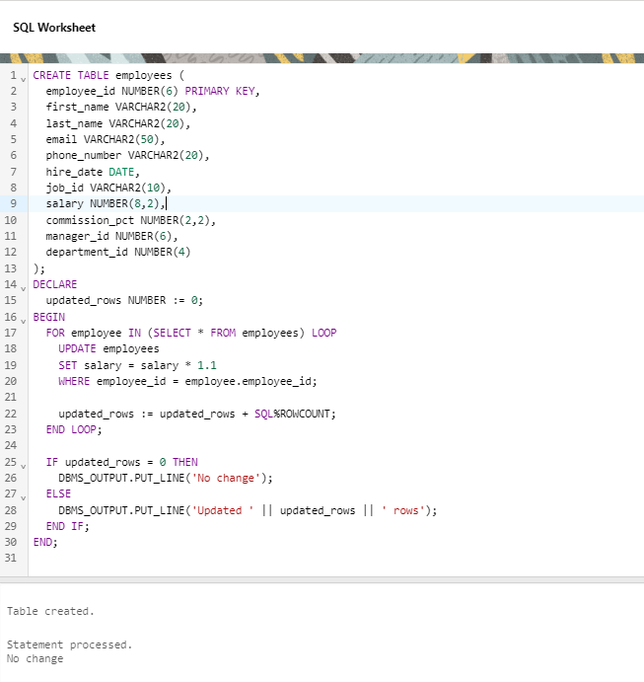Q1- Using implicit cursor update the salary by an increase of 10% for all the records in EMPLOYEES table, and finally display how many records have been updated. If no records exist display the message “No Change”

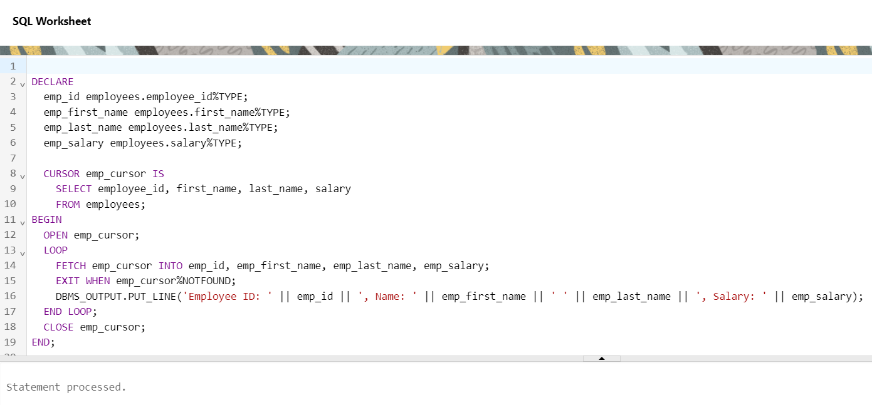Q2- Using explicit cursor fetch the employee name, employee and salary of all the records from EMPLOYEES table.

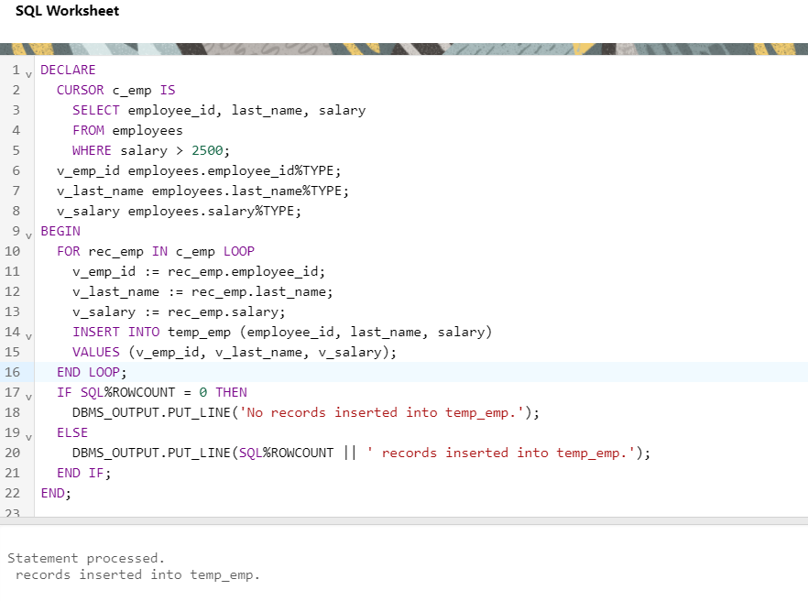Q3- Using explicit cursor Insert the records from EMPLOYEES table for the column’s employee_id, Last_Name and salary for those records whose salary exceeds 2500 into anew table TEMP_EMP